Name: Grade: Teacher: Date:

1. Read the short-story and find 3 examples of the present perfect tense. Write them down in the boxes below.

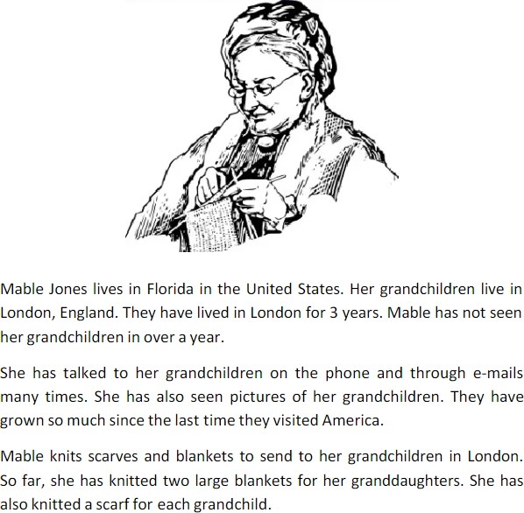

|  |  |
| --- | --- |
| Example 1 | Lived |
| Example 2 | Talked |
| Example 3 | Knitted |

1. Complete the chart with the correct form of the verb. (Look at the example.)

|  |  |  |  |
| --- | --- | --- | --- |
|  | **Base form** | **Past Simple** | **Past Participle** |
| 1 | Give | Gave | Given |
| 2 | Know | Knew | known |
| 3 | Work | Worked | Worken |
| 4 | Speak | Spoke | spoken |
| 5 | go | Went | gone |
| 6 | Saw | saw | Seen |
| 7 | Come | came | Come |
| 8 | Find | Found | Found |
| 9 | Call | Called | Called |
| 10 | Make | Made | Made |

1. Put the 3 sentences in the correct order
2. I / have / all / today / watched / movies / Avengers.

I have watched movies avengers all today.

1. acted / Silvester Stalone / has / since / in / more / than / 1970 / 50 movies.

Silvester Stalone acted has in more than 50 movies since 1970

1. I / haven’t / movie / watched / yet / that.

I haven’t watched movie that yet.

1. Choose the correct verb from the list below to complete the following sentences. Put the verb in the present perfect tense.

win - complete – work – have - pay

1. I complete my homework yet.
2. My father work for Apple since 2005.
3. My family pay Netflix yet this month.
4. Mathias have amazing scores since he studies at Algarrobos.
5. Peru wins the Copa America yet.

5. Write two questions using the word yet and two sentences using the word since.

1. The mail hasent arrived yet.

2. She hasnt called yet

**NUEV**

3. I have worked for my uncle since June

4. It has been snowing since 10 o clock