A2+: Worksheet 1: 18/06- Vocabulary Builder

JOSEP VILCHERRES GUARNIZ

1. Look at the vocabulary list on page 72 and write 5 sentence with the following words:
   1. Knowledge: The two entities have a problem with knowledge and recognition.
   2. Creativity: The best tool we can have right now is our creativity.
   3. Review: The review of countries is based on three reports.
   4. Tip: And he insisted on beigin the tip of our spear.
   5. Absolutely: There’s very few things in life that are absolutely free
2. Describe the pictures with the correct word from the vocabulary list

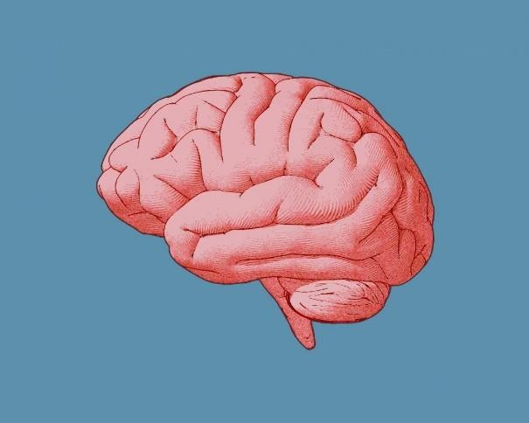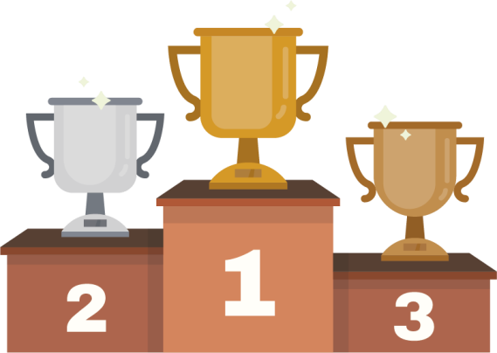

The brain is what makes us intelligent the trophies are absolutely precious



I put five stars on the form