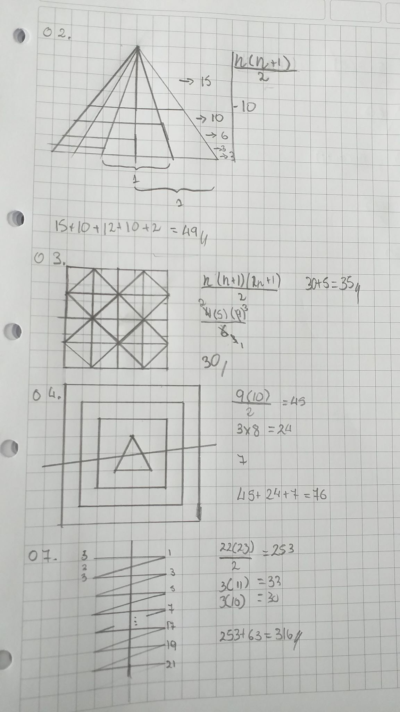

NICOLÁS ALBUJAR NUÉ (2, 3, 4, 5, 6, 7)

FRANK SÁNCHEZ CHÁVEZ (8, 9, 10, 11, 12, 13)

CARLOS QUEREVALÚ VÁSQUEZ (14, 15, 16, 17, 18, 19, 1)

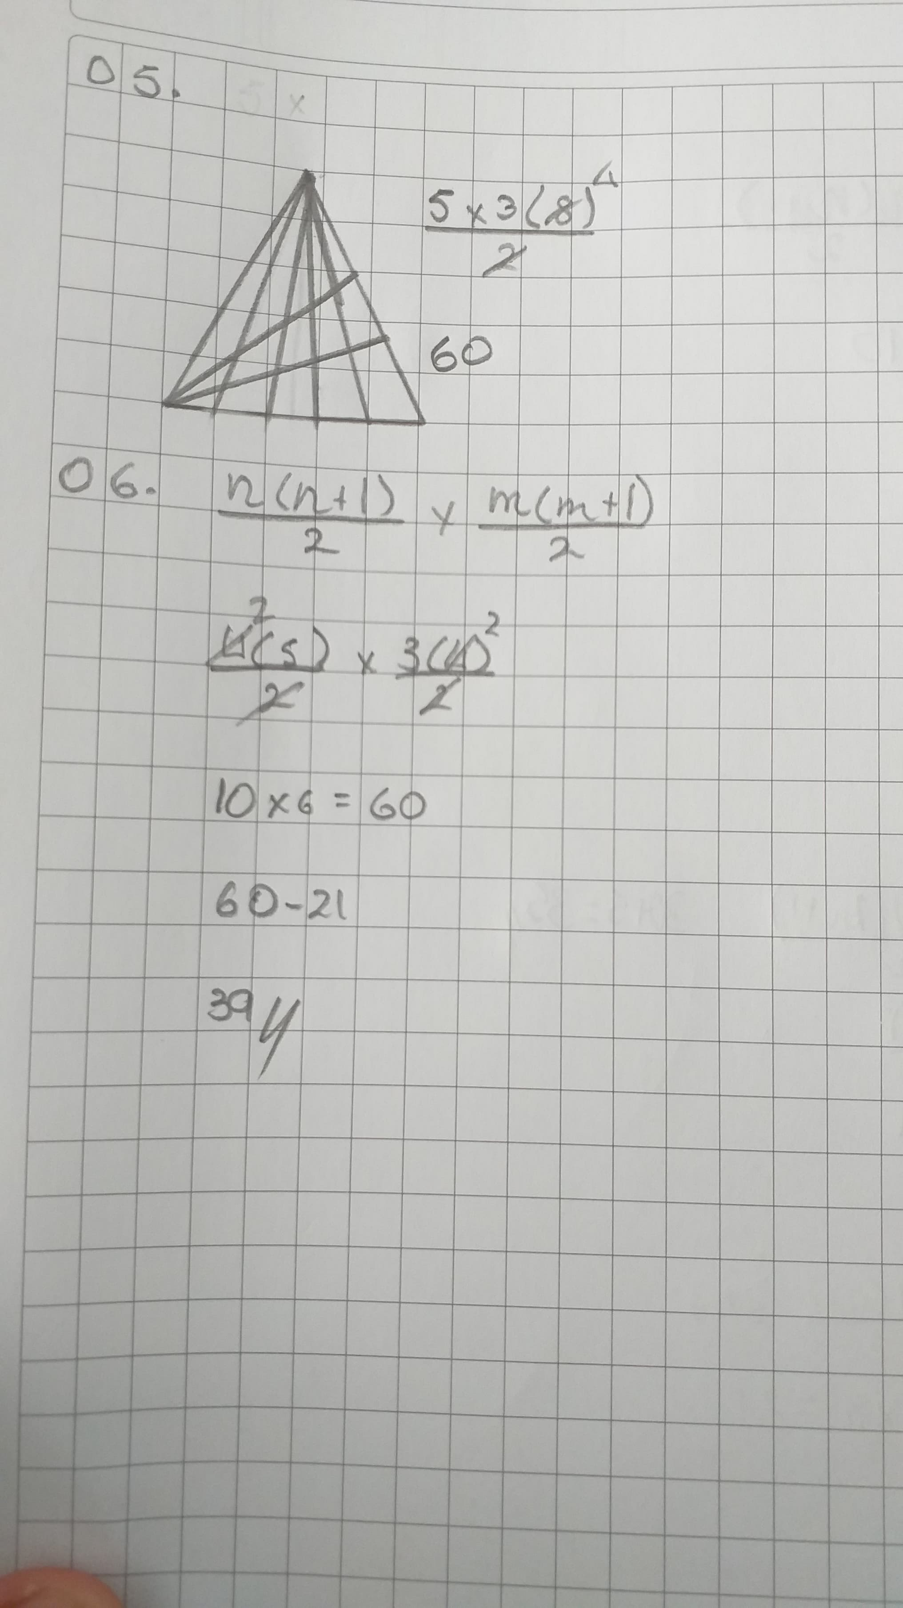

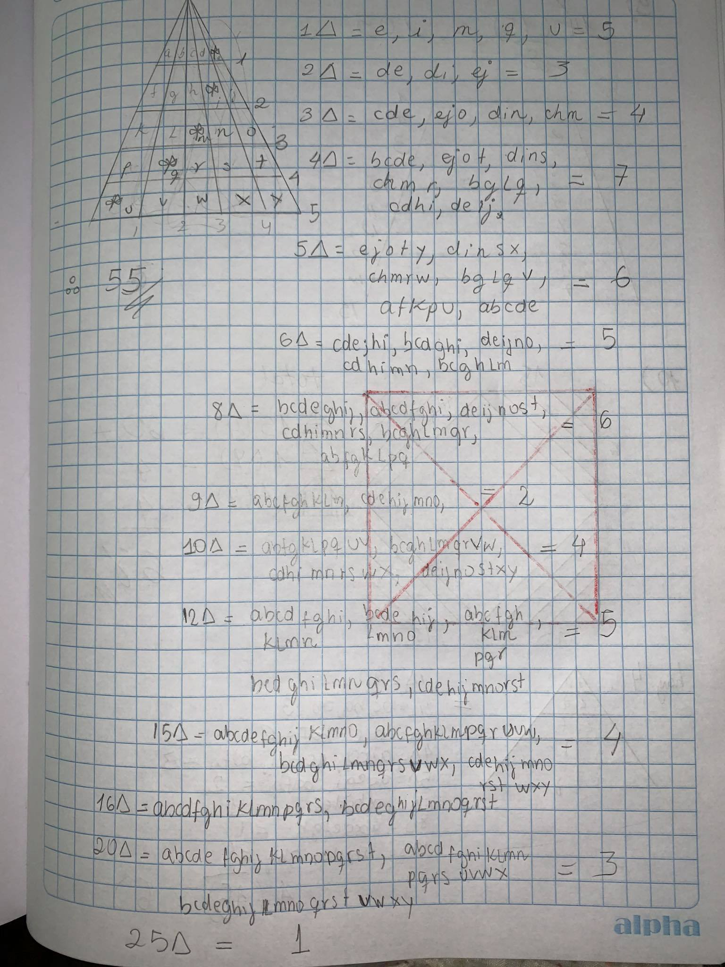

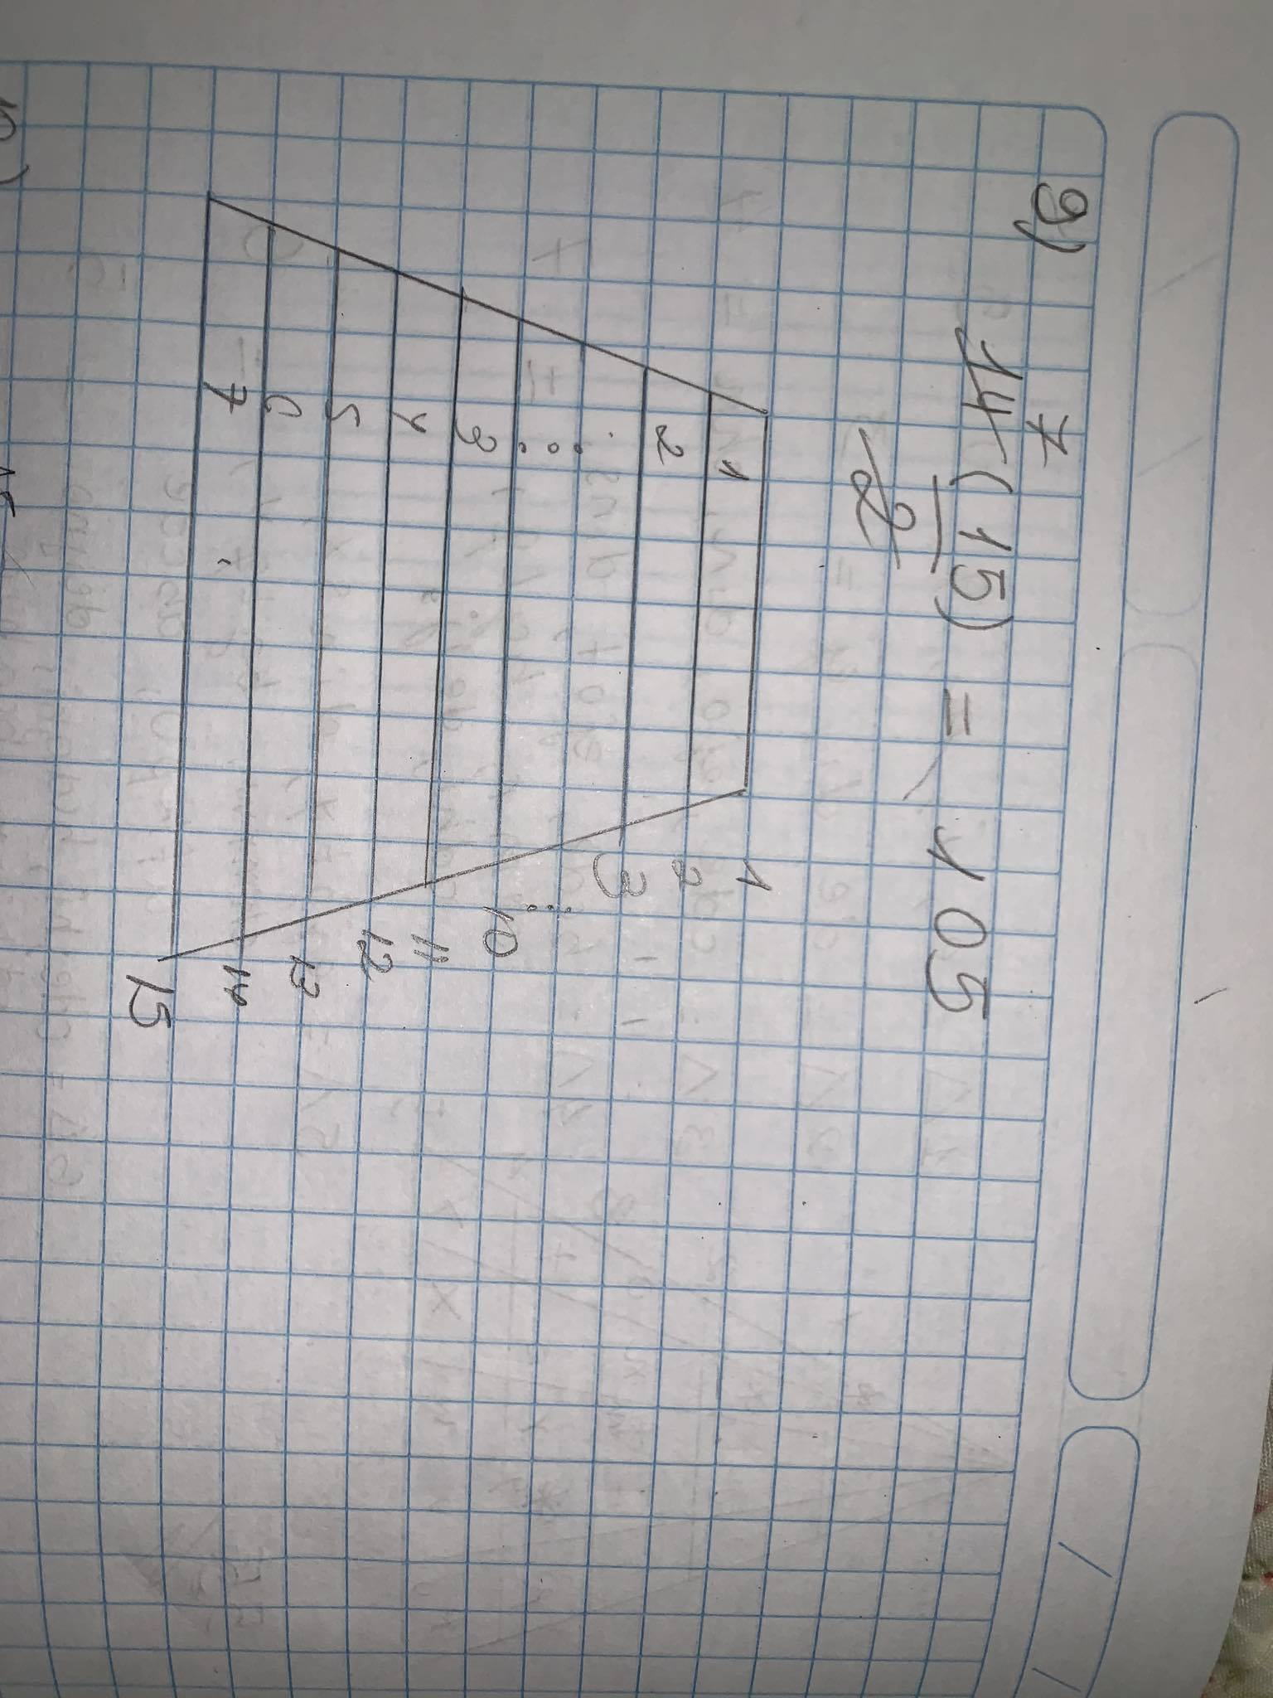

}

}

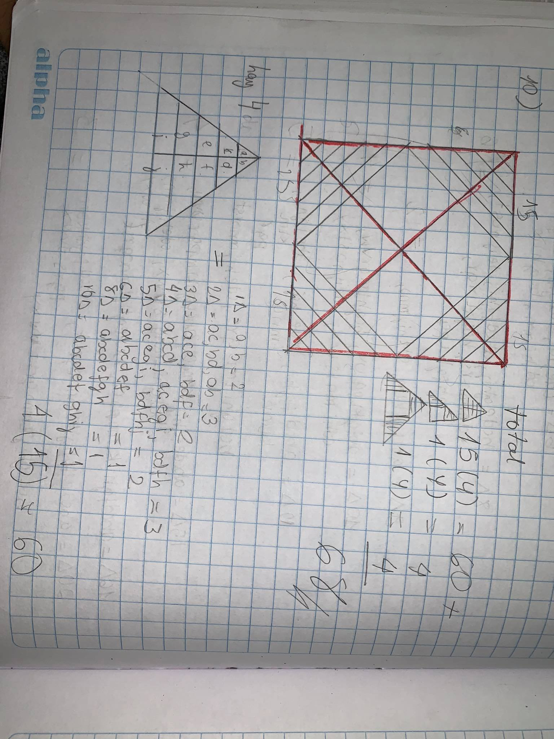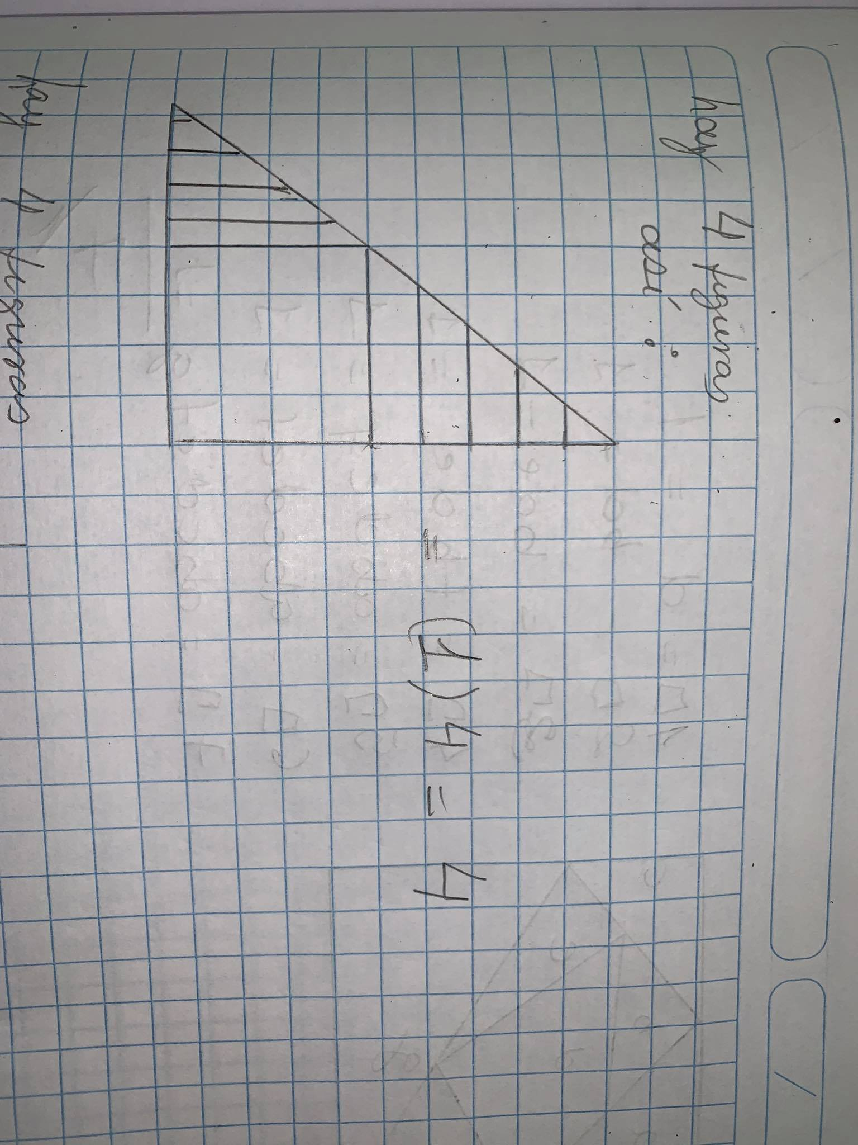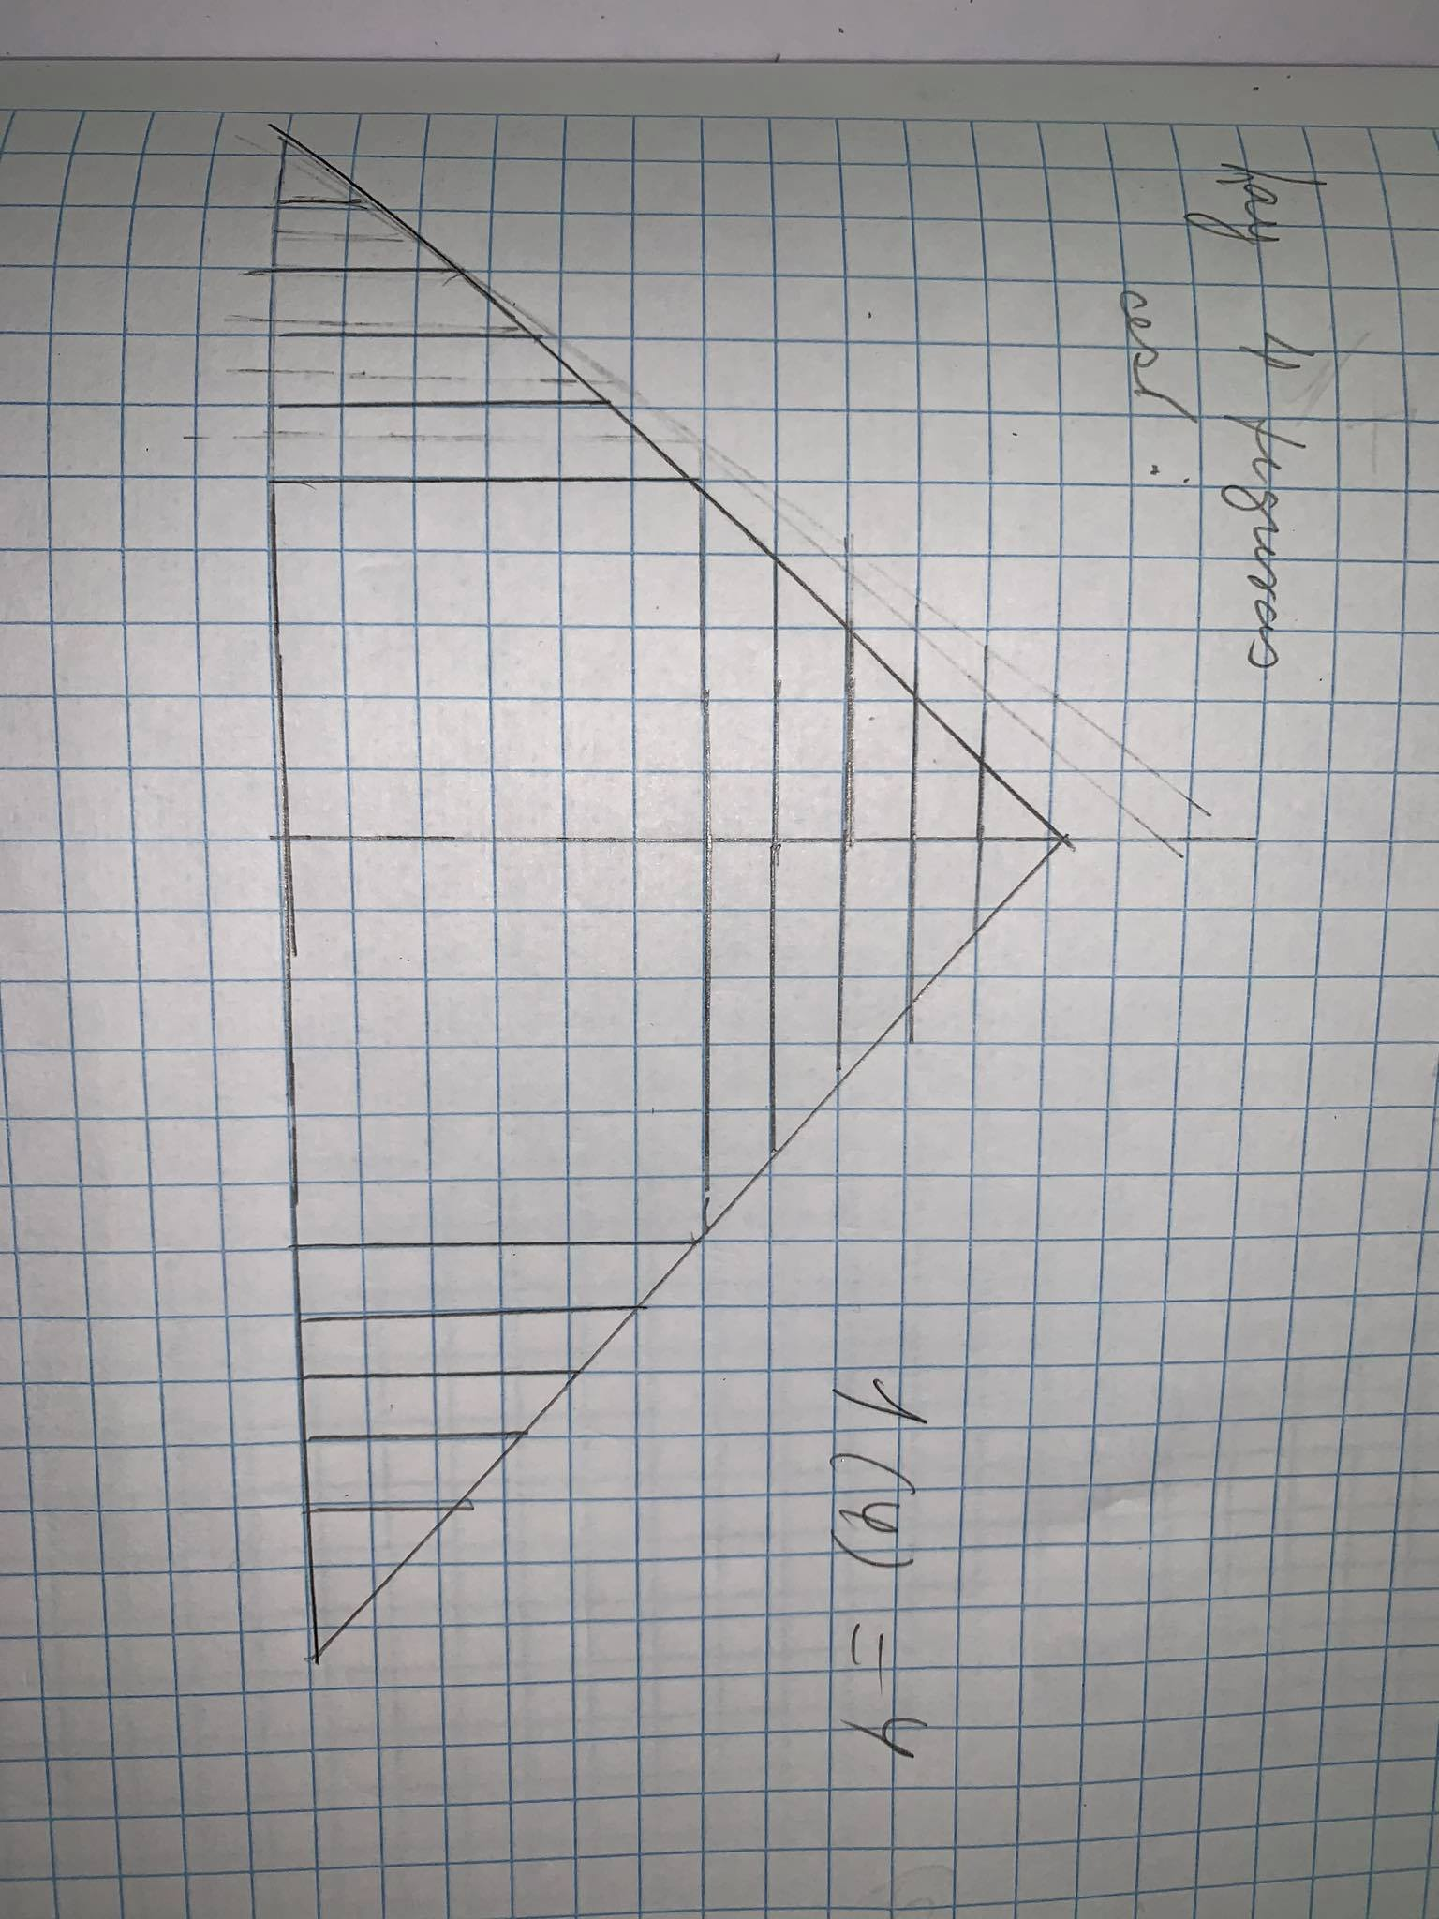

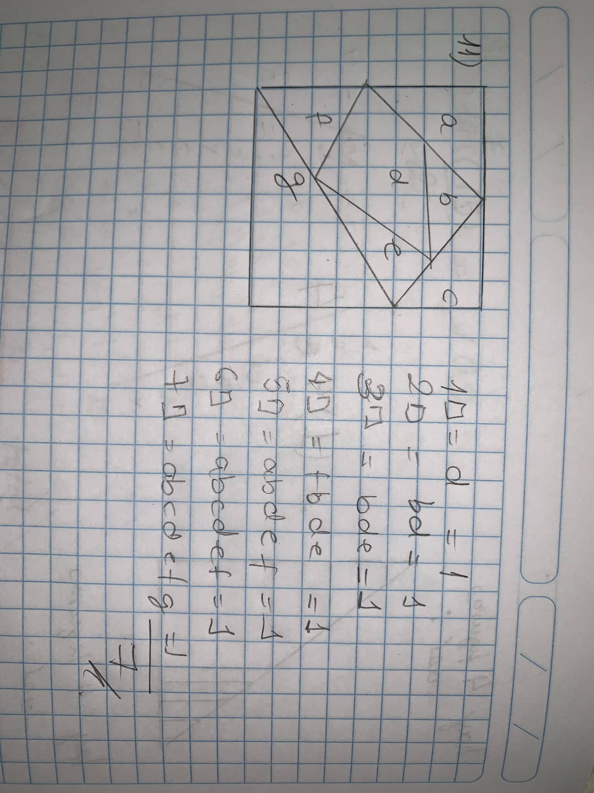

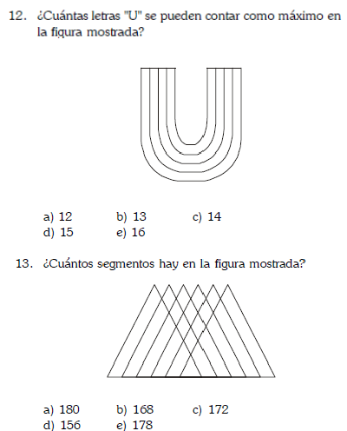

1+1+3+6+10+15+21+21+10+15+6+3+66

TOTAL: 178

FORMULA UTILIZADA PARA HALLAR SEGMENTOS

N(N+1)/2

1

1

21 15 10 6 3

3 6 10 15 21

[11(12)]/2 =66

NO HAY ALTERNATIVA

1 2 3 4

[4(5)]/2

2(5) = 10

