**GEAR UP! 6TH PRACTICE TEST – INTRANET**

**Read each sentence and complete it with the correct word.**

1. I just got a _______text message_______ from mum. She says I need to take out the dog for a walk.
2. Nicolas always uses his ____tablet_________ to watch videos when he’s bored.
3. When I went to Cuzco, I used my ______camera________ to take lots of pictures of Machu Picchu.
4. George had a cold, tingling _____sensation________ entering his body.
5. The teacher told some students they need to _______improve______ in the classes to pass the exams**.**
6. John said, “I’m _____pleased_______ to meet you”.
7. We were surfing the Web and the ______internet_______ went off.
8. I think ____cartons_______ are for kids but I sometimes watch them with my little brother.

TABLET / CAMERA / CARTOONS / PLEASED / TEXT MESSAGE / SENSATION / PLEASED / INTERNET

**Look at the pictures and choose the best *past participle verb* that completes the sentences.**

1. My little cousin has ____gone______ a present for Christmas. ***(gotten/ gone / tasted)***



1. Dereck’s dog has _______eaten____ his mathematics homework. ***(done / eaten / completed)***

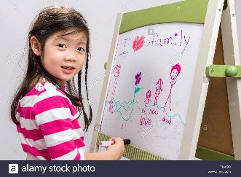

1. Estella has _____drawn______ a beautiful picture of her and her family. ***(looked / drawn / done)***
2. Luis’s parents have _____driven _______ their car after that accident they had. ***(driven / gotten /gone)***

**Read each sentence and complete them with the correct object pronouns.**

1. I cannot see **Kate**. Have you seen _____her___?
2. **We** are hungry. Please give ___us____ a sandwich.
3. **I** can’t ride a bike. Please help ___me____.
4. The **windows** are open. Could you please close ____it____?
5. Emma is next to **David**. Emma is next to _____him____.
6. I can’t believe you forgot **Alex’s** birthday. Didn’t you say hi to ____him___?