# Unit 6: Writing & Reading: Table Manners

Name: Jardel Iván Fernández Silva

Date: Wednesday twenty nineth(29th) of September 20212

Read the text about table manners from around the world and answer the questions below:

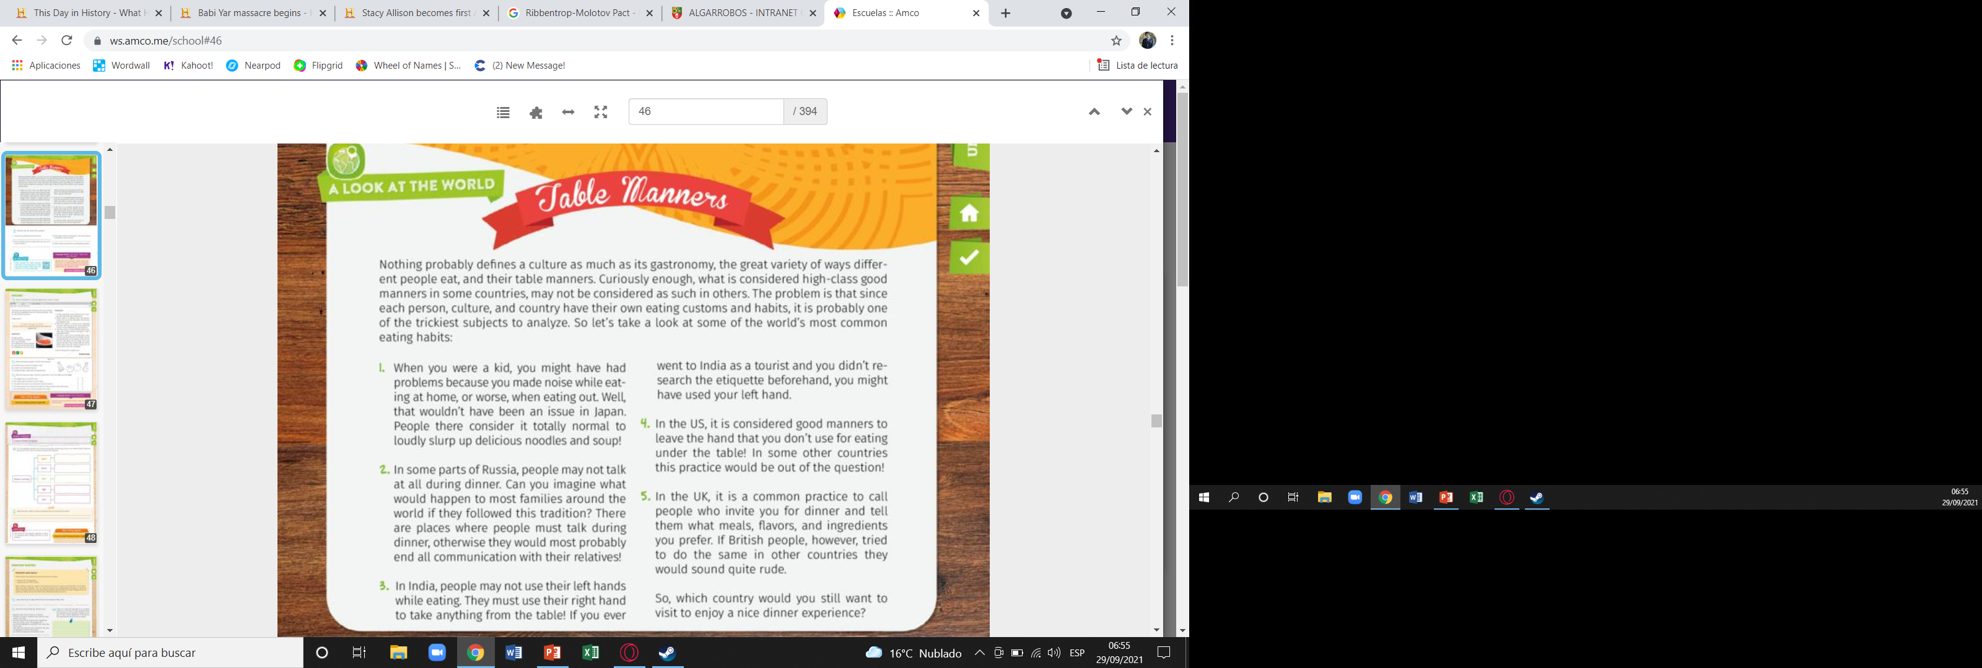

1. How your your table manners at home?

My table manners are not to speak out loud, not to use my phone or watch TV while I eat, not to stop until the rest are done and thank you for the food

1. How do table manners change when you eat out or at your friends’?

They´re the same, but washing my plate, and offering some service if they want to.

1. What table manners mentioned in the text would be acceptable in your country?

The table manners that would be acceptables are those of US and India because the peruvians can conform to these.

1. Which of them would you be uncomfortable to follow?

I would be uncomfortable with Russia and UK because are so rare for me.