# Unit 6: Writing: Cover Letter

Name: Greggory Vasquez Gomez

Date: 30/09/2021

Read the letter and answer the questions below with “**true**”, “**false**” or “**doesn’t** **say**”:

B 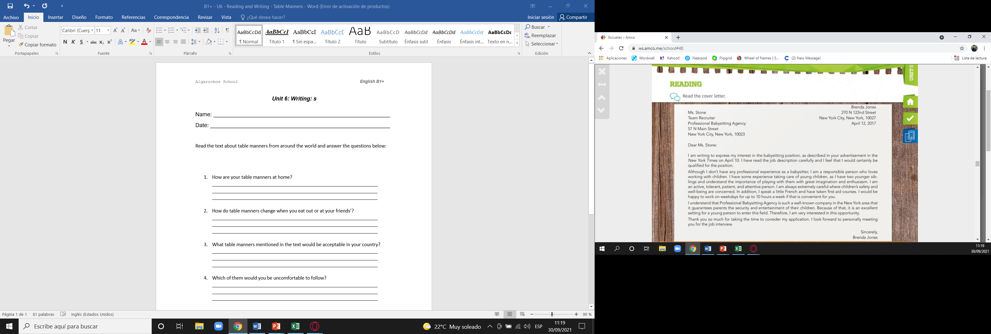

|  |  |  |  |
| --- | --- | --- | --- |
| The cover letter includes Brenda’s exact age. | T | F | DS |
| She is applying for a part-time job. | T | F | DS |
| Brenda has already worked as a babbysitter. | T | F | DS |
| Brenda includes her parents’ personal information in her application. | T | F | DS |
| She lives in the United States. | T | F | DS |
| She cannot work at nights. | T | F | DS |

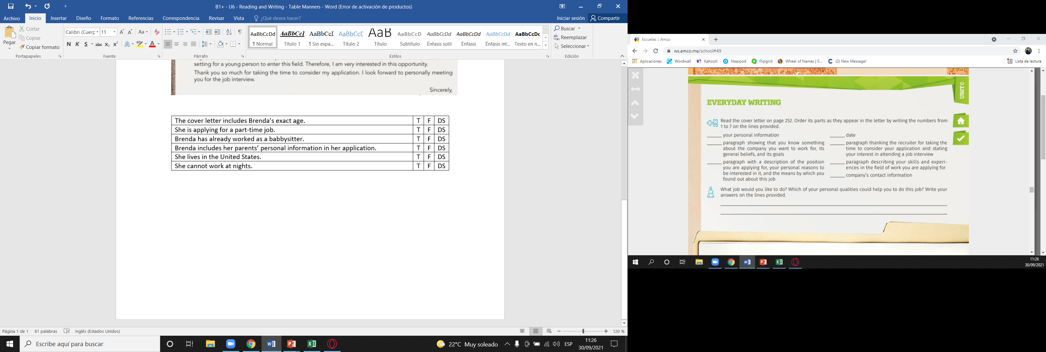

* Date
* Company’s contact information
* Your personal information
* Paragraph with a description of the position you are applying for, your personal reasons to be interested in it, and the means by which you found out about this job
* Paragraph describing your skills and experiences in the field of woek you are applying for
* Paragraph showing that you know something about the company you want to work for, its general beliefs, and its goals
* Paragraph thanking the recruiter for taking the time to consider you application and stating your interest in attending a job interview

Now write your own letter applying for a job of your choice. Remember to use the structure given in the book.

In your letter you must include the following:

* Personal information.
* Some information showing you know about the company you are applying for.
* Some information on the position you are applying for.
* Your contact information.

Your letter must be between **200 and 250** words.