B1 Worksheet 2: 25/06 –This/That/These/Those

Change the following sentences from singular to plural (look at the example)

- This book is good A. These books are good
- That girl has a doll B. That girl has some dolls
- This office is near the bank C. These offices are near the bank
- That is my notebook D. Those are my notebooks
- This boy is 14 years old E. These children are 14 years old

Correct the mistakes (look at the example)

- Those car is beautiful A. That car is beautiful
- That bags are expensive B. ________________
- Take this keys C. ________________
- Give me those shirt D. ________________
- This is my father E. ________________

Describe the pictures using the correct demonstrative pronouns

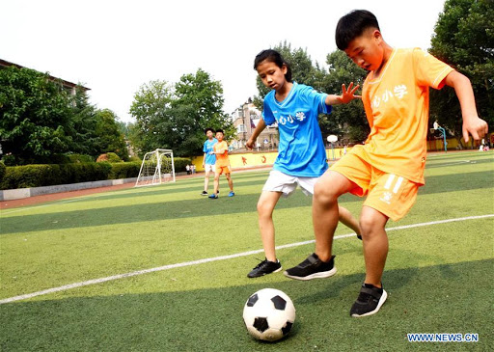 | 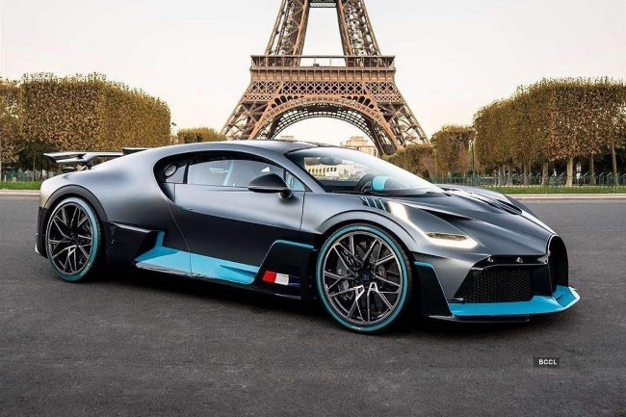
those players are good | that car is expensive

