**GEAR UP! 5TH ENGLISH EXAM – INTRANET**

**LISTENING (3 points)**

**Listen to the conversation and choose TRUE or FALSE**

1. Mom says she’s upset to be in California. (V)
2. Anna says the hotel room is beautiful. (V)
3. The family has to unpack before going to lunch. (V)
4. Mom says she saw a nice restaurant on the way to the airport. (F)
5. At the restaurant they serve all kinds of food. (V)
6. Mark says he wants to go to the museum after they have lunch. (F)

**READING (6 points)**

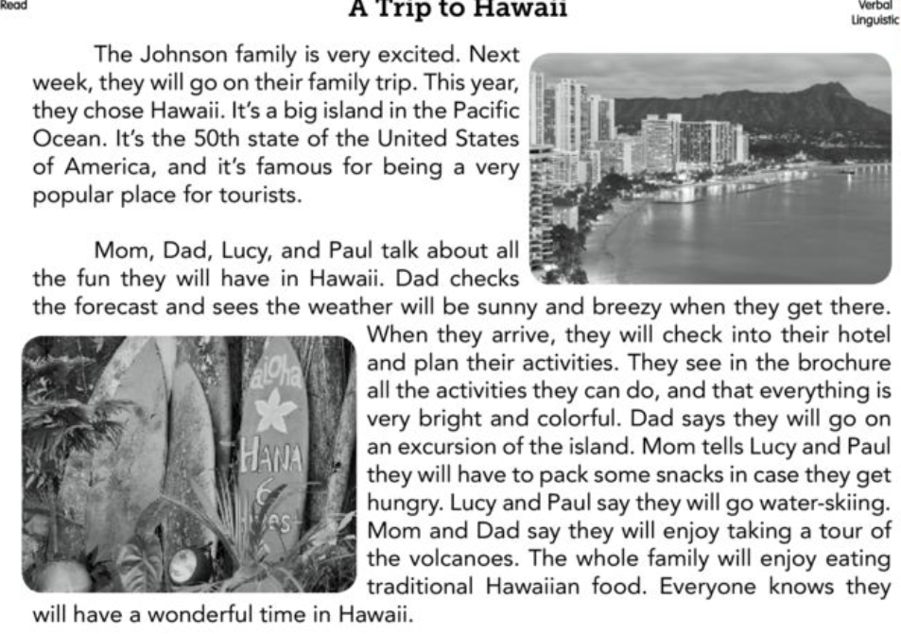**Read the story and choose the right answer.**

1. Where will the Johnson family go on their yearly trip?

**The family the Johnson will a Hawaii yearly trip.**

1. Where is Hawaii located?

**Hawaii is located will in the big island in the Pacific OCEAN.**

1. How does Dad know about the weather?

Does Dad check the forecast and see that the weather is sunny and windy.

1. What kind of weather will there be in Hawaii?

Weather will there be in Hawaii is sunny.

1. Will they stay at a hotel or in a bungalow?

They will stay at a hotel.

1. What do they see in the brochure?

The brochure will all the activities what: on excursion and island, water skiing and tour of volcanoes.

**He checked the forecast/ At a hotel / Activities they can do / To Hawaii / Sunny and breezy /In the Pacific Ocean**

**VOCABULARY & GRAMMAR (12 points)**

**Read each sentence and choose the best word that completes it. (7 points)**

1. My dad bought the plane flight for September 23rd. ()
2. Our sailing was packed and ready for the trip. ()
3. I bought tickets for the beach. ()
4. My family and I want to go forecast in the ocean. ()
5. Our sandals was delayed due to bad weather. ()
6. This is a description of what is likely to happen in the future with the weather. ()
7. The new subway station is luggage. ()

**Sailing / underground / forecast/ tickets / luggage / sandals / flight**

**Read the sentences and decide which words completes the sentences. (4 points)**

1. Having two vaccines ay the same time is the worse experience. (bad/ worse/worst)
2. Visiting Disneyland is the better thing in the world! (best/good/ better)
3. Studying for math is badder than studying for science. (bad/worse/badder)
4. Scuba diving is better than taking a tour in the woods. (good/gooder/better)