A2+: Worksheet 1: 18/06 - Vocabulary Builder

A. Look at the vocabulary list on page 72 and write 5 sentence with the following words:

1. Pleasant: My neighbor is pleasent.
2. Performance: Saturday's performance was very Good.

1. Boring: This game seems boring to me.

1. Show: My brother did not arrive on time to the show.

1. Costumes: I really like the costumes of my Friends.

B.

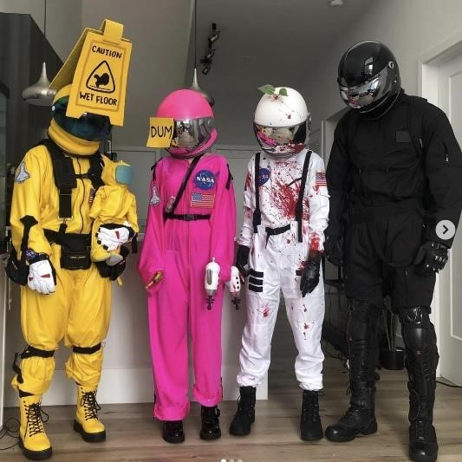

TUNE

COSTUMES