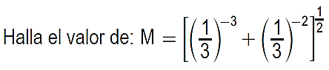

1.

[(3)3 + (3)2] ½

[27 + 9] ½

[36] ½

6

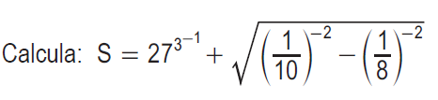

2.

[27] 1/3 +

+

3 + $\sqrt{36}$

3 + 36 = 9

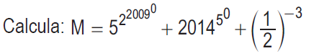

3.

+ +

+ 2014 + 8

25 + 2014 + 8

2047

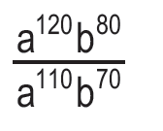

Efectúa:

4.

$a^{120-110}$. $b^{80-70}$

$a^{10}$. $b^{10}$

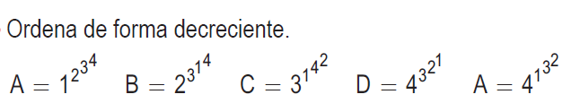

5.

A = $1^{2^{81}}$ B = $2^{3^{1}}$ C = $3^{1^{16}}$ D = $4^{3^{2}}$ A = $4^{1^{9}}$

A = $1^{…}$ B = $2^{3}$ C = $3^{1}$ D = $4^{9}$ A = $4^{9}$

A = 1 B = 8 C = 3 D = 262,144 A = 4

Forma de decrecion:

D = 262,144B ; B = 8 ; A = 4 ; C = 3 ; A = 1



Efectúa:

6.

$\frac{2^{10+12+14}}{2^{9+7+20}}$ = $\frac{2^{36}}{2^{36}}$ = $2^{36-36}$ = $2^{0}$ = 1



Efectúa:

7.

$\frac{3^{5+7+9+11+13}}{3^{18+10+15}}$ = $\frac{3^{45}}{3^{43}}$ = $3^{45-43}$ = $3^{2}$ = 9

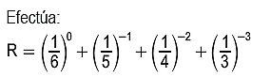

8.



+ + +

1 + 5 + 16 + 27

49