Colegio Algarrobos English - 2° Grade of Primary

**UniT IV “Let´s promote family union”**

**”**

**Unit Exam**

**Name**: ________________________ **Date**: __________

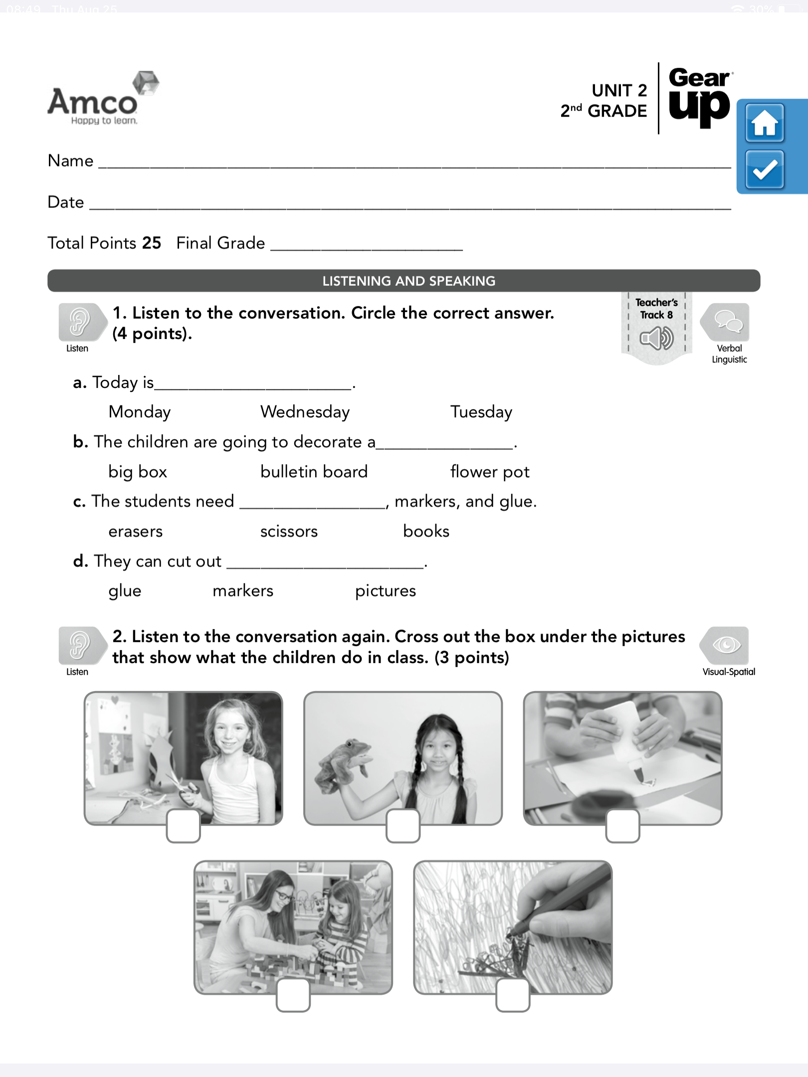

1. **Listen** to the conversation again. **Cross** out the box under the correct pictures that show what the children do in class.
2. **Listen** to the conversation. **Circle** the correct answer.

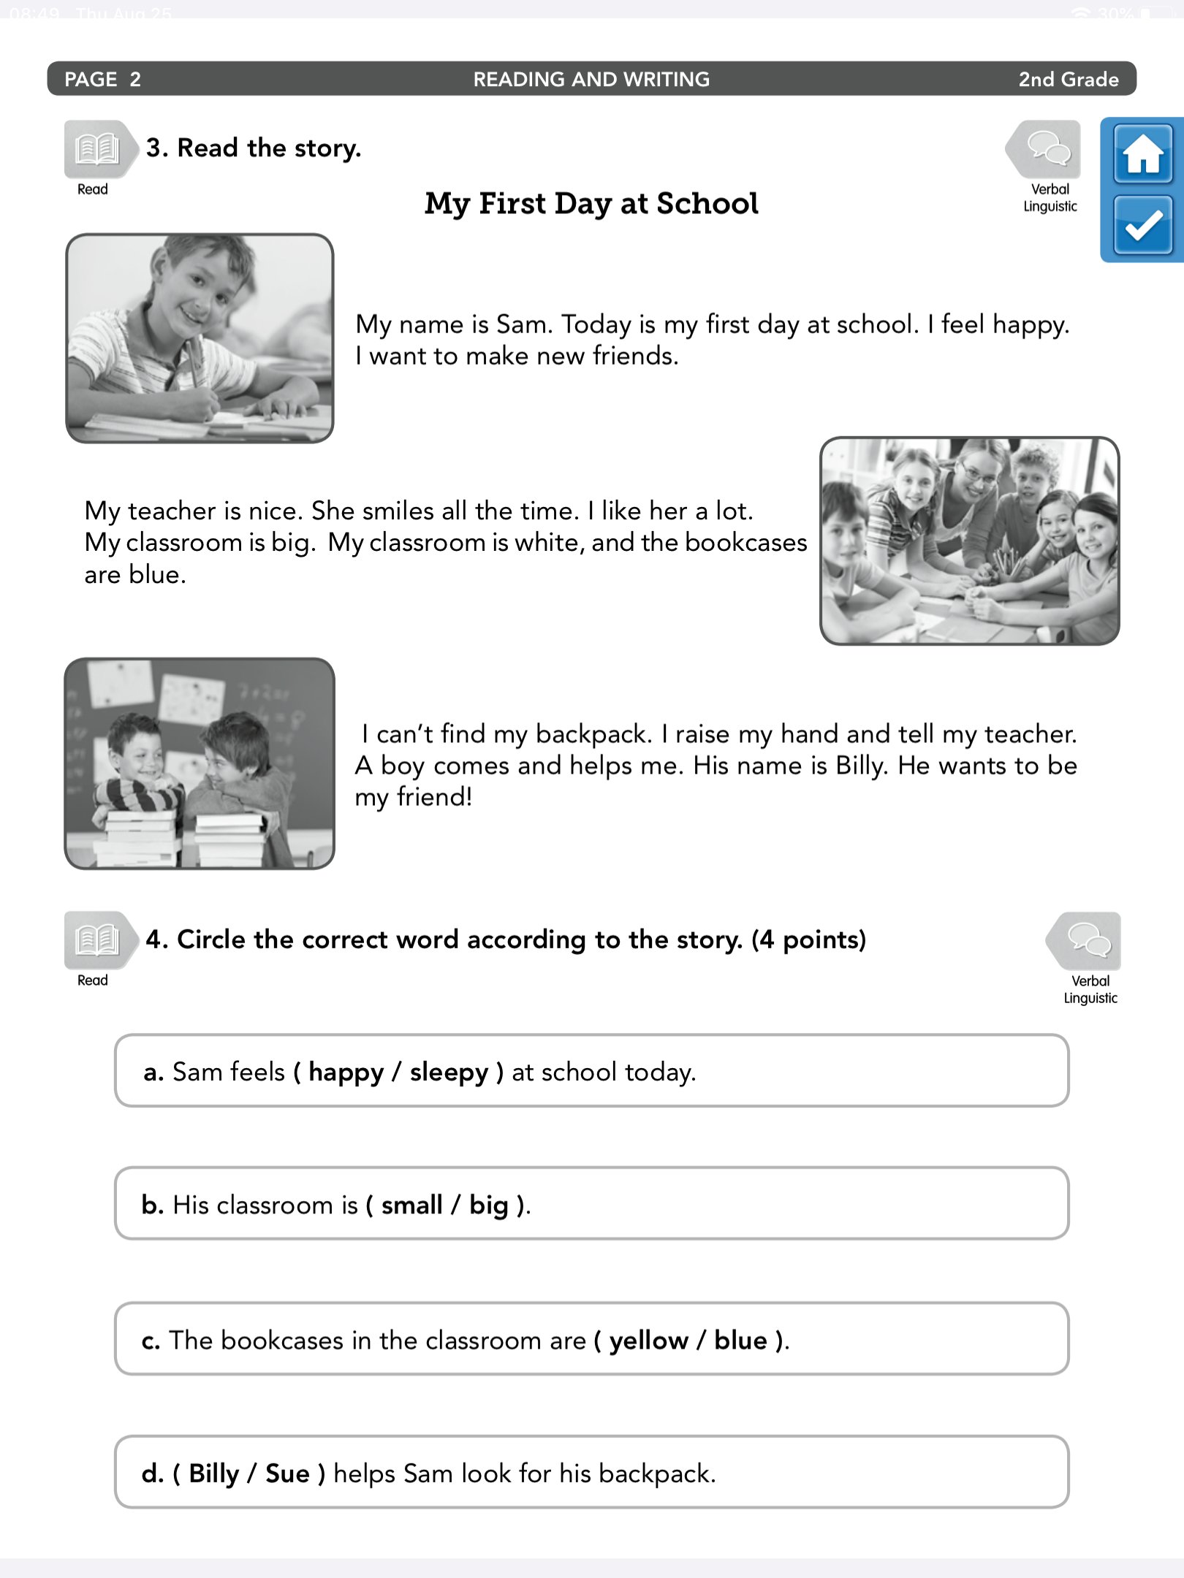

**4.** **Circle** the correct word according to the story.

3. **Read** the story.

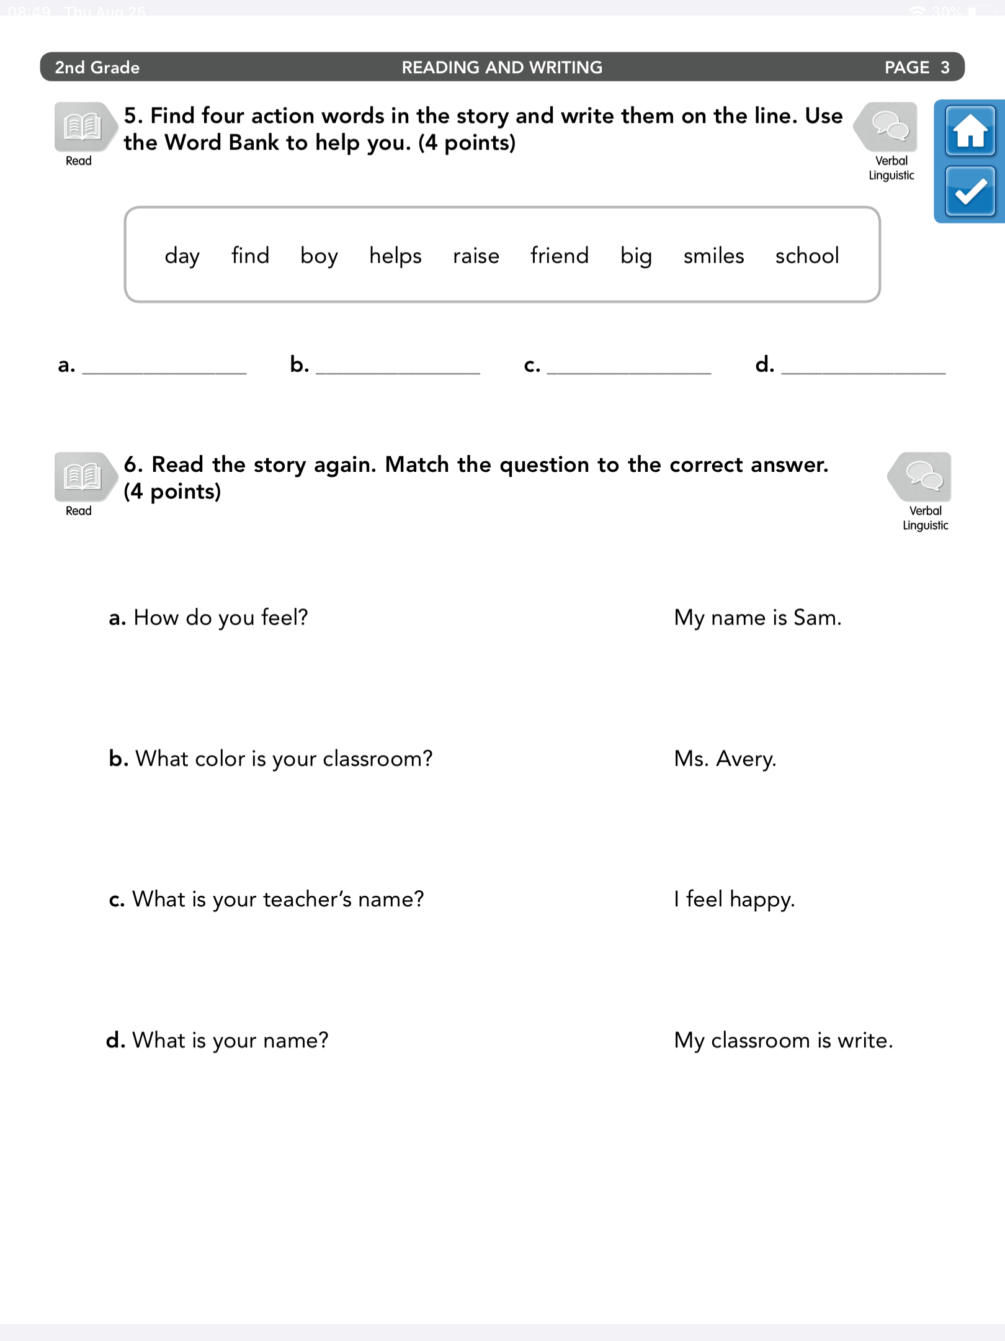

**5. Find** four action words in the story and write them on the line. Use the Word Bank to help you.

**6. Read** the story again. **Match** the question to the correct answer.

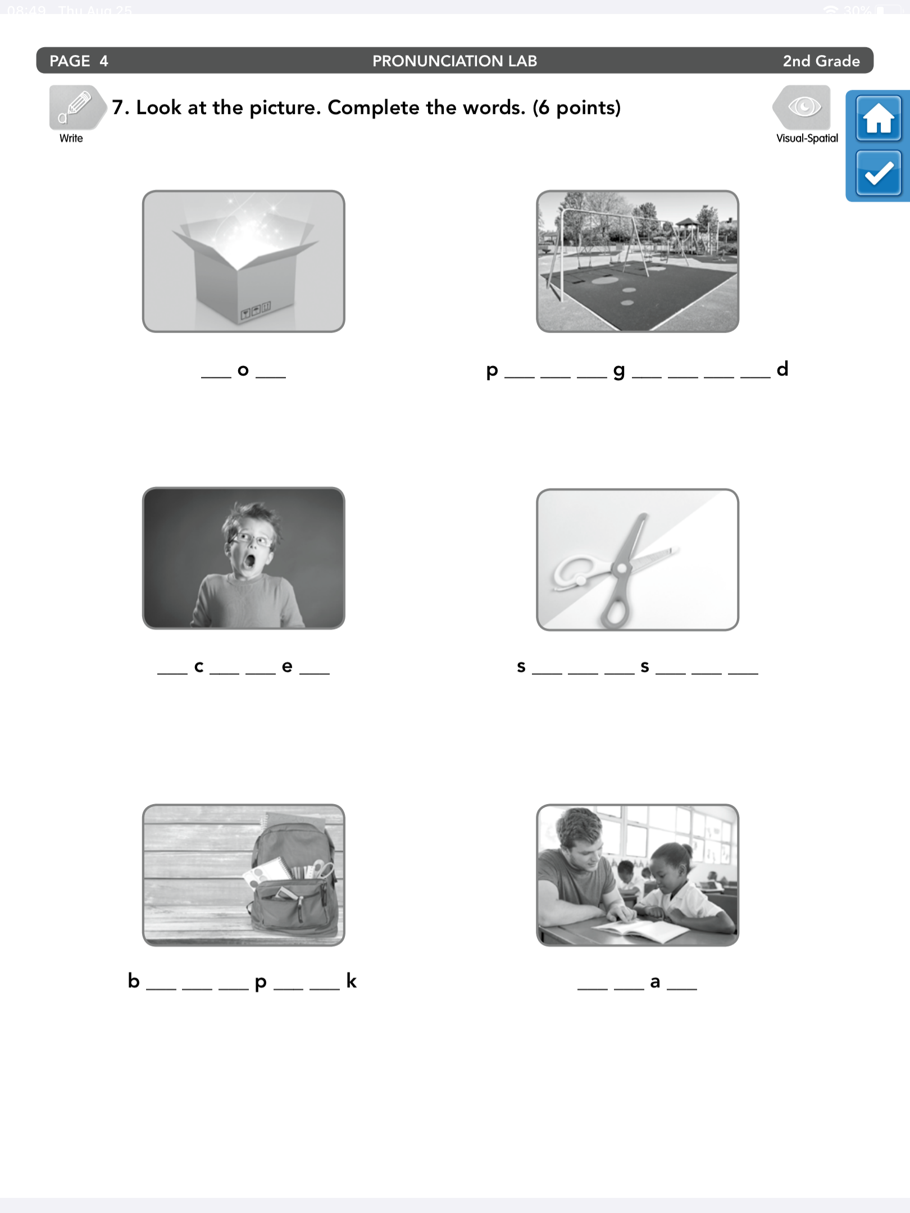

**7. Look** at the pictures. **Complete** the words.