<file:///C:/Users/USER/Downloads/Dialnet-AntecedentesDeLaFuncionYLaEstructuraDelADNIdentifi-6072411.pdf>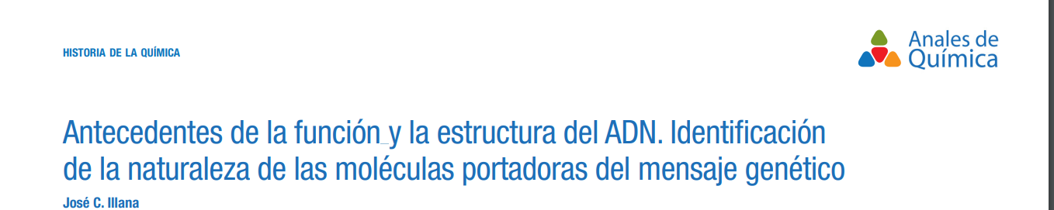

<file:///C:/Users/USER/Downloads/ROSALIN%20FRANKLIN.pdf>

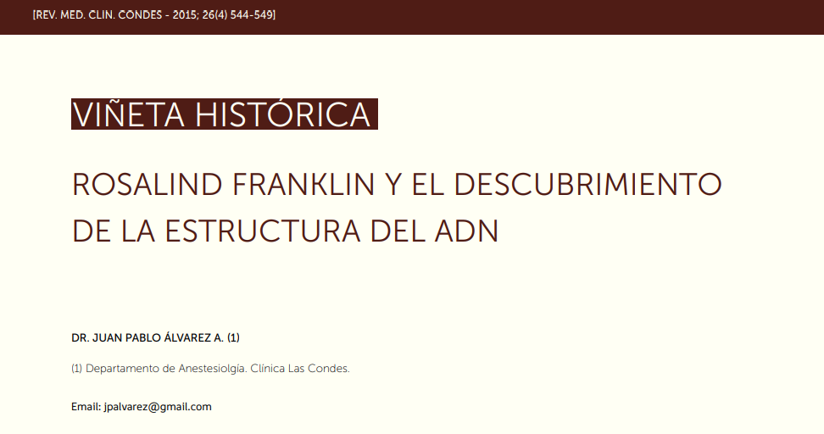

<https://elpais.com/sociedad/2003/04/25/actualidad/1051221601_850215.html>

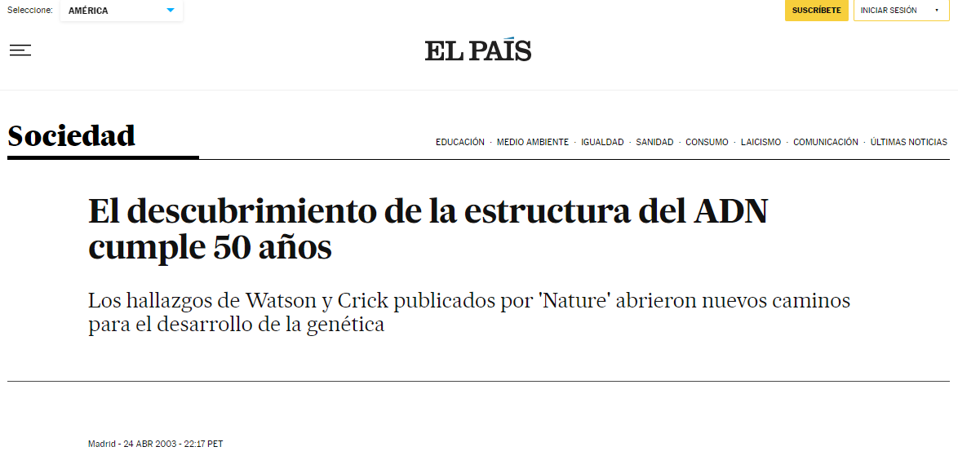

<https://www.dgcs.unam.mx/boletin/bdboletin/2013_364.html>

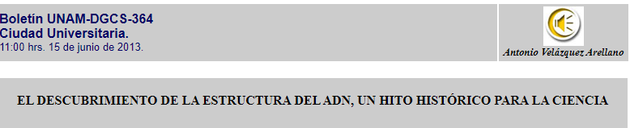

<https://www.chilebio.cl/el-adn-los-genes-y-el-codigo-genetico/>

