B1: Worksheet 3: 02/07 - Vocabulary Builder

Look at the vocabulary list on page 72 and look for the words that rhyme with the words below
- Release ____ research___
- Inception _____ form_______
- interview ____ technique___
- activist _________________
- sufficient ___ absolutely______

Look at the pictures and write 1 sentence about each one: (use words from the vocabulary list on page 72)
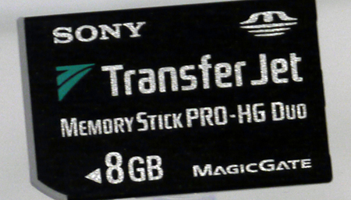 | 
- SONY DVD has a capacity of 8GB | - The scientist is going to review the sample.
 | 
- Albert Einstein was a good scientist | - the dollar increases every day

