Name: Benjamin Hernandez Grade: 1°A Teacher: Louis Gysels Date: ____________

1.Read the short story and answer the questions below.



+

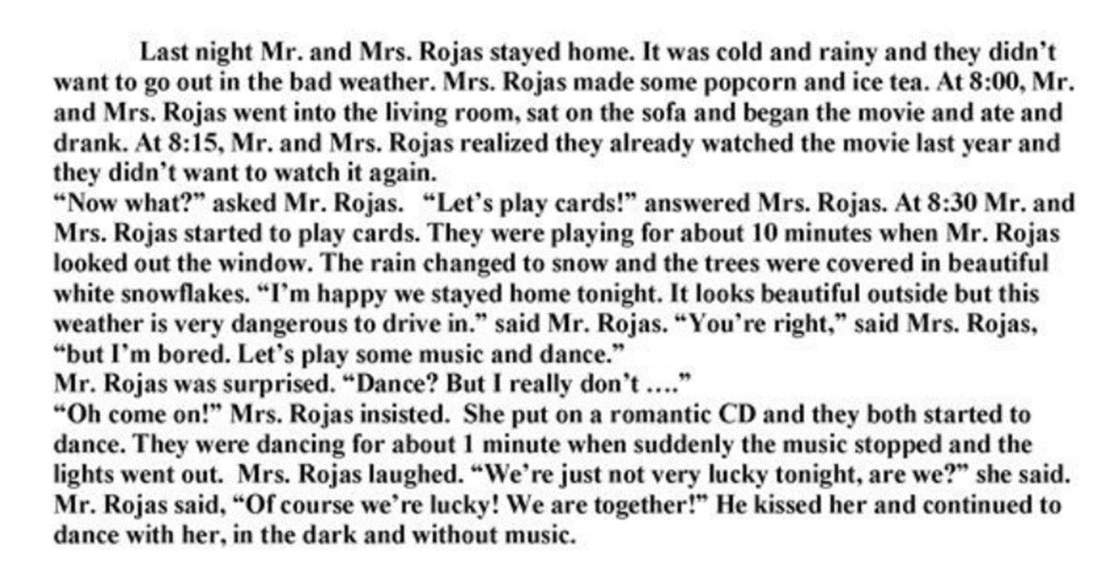

1. Q: Why did Mr. and Mrs. Rojas stay at home?

A: They stayed at home because outside was cold and rainy.

1. Q: What did Mrs. Rojas make?

A: They made some popcorn and ice tea.

1. Q: What were they doing when it started to snow?

A: They played some music and started to dance.

1. Q: Why was Mr. Rojas happy they stayed at home?

A: He was happy because the outside looks beatiful.

1. What were they doing when the lights went out?

A: They laughed and continued to dance without music.

1. Read the story again and find 5 regular verbs and 5 irregular verbs in the past simple. Write them down in the box below.





+

|  |  |
| --- | --- |
| **Regular Verbs** | **Irregular Verbs** |
| Stay - stayed | Do – didn’t |
| Laugh- laughed | Make - made |
| Look - looked | Go - went |
| Change - changed | Sit - sat |
| Cover- covered | Begin - began |

1. Answer the following question: “What did you do yesterday?”

Yesterday, I did my homework, then, I played videogames