My vacation collage

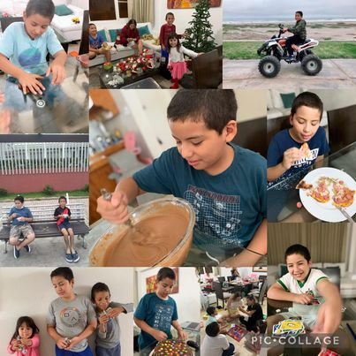

Last summer, i cooked a lot of desserts, i played with my siblings, i rode a quad bike. I live in Pimentel so I went to the beach every day.

I played Pictionary, ps4 and a lot of games