A2+: Worksheet 1: 18/06 - Vocabulary Builder

Look at the vocabulary list on page 72 and look for the words that rhyme with the words below
- Bigger: Singer
- Right light
- Grow sit down.
- June tune
- Green screen

Look at the pictures and write 1 sentence about each one: (use words from the vocabulary list on page 72)

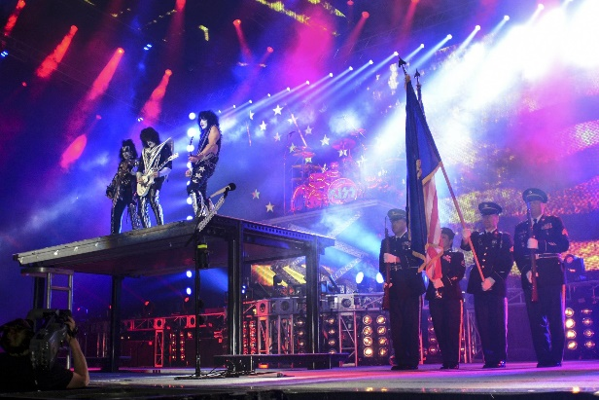 | 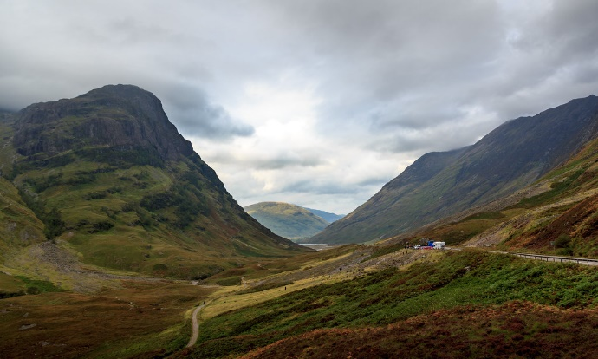
- Singer: one of my favorite singers is coming to town this summer _______________________________  _______________________________  _______________________________ | - Screen: He was horrified at some of the images he saw on the screen _______________________________  _______________________________  _______________________________
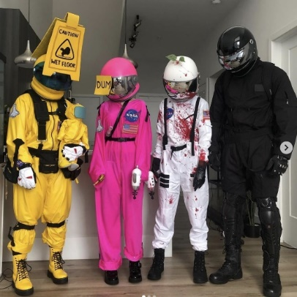 | 
- Play: the actors who performed the play Macbeth were good _______________________________  _______________________________  _______________________________ | - Boring: My brother doesn’t like homework _______________________________  _______________________________  _______________________________

