1. Si AB = 3(BC) y AC = 20. Calcula AB.

A B C

X

3(BC)

20

AB + BC = AC Calcular AB

3(BC) + x = 20 AB = 3(BC)

3(x) + x = 20 AB = 3(X)

3x + x = 20 AB = 3(5)

4x = 20 AB = 15

X = 5 Rpta: AB vale 15

2. En el gráfico si: AC + BD = 24. Calcular AD.

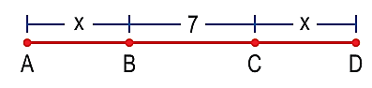

AC + BD = 24 AB +BC +CD = AD

X + 7 + 7+ X = 24 X + 7 + X = AD

14 + 2X = 24 5 + 7 + 5 = AD

2X =10 17 = AD

X =5 Rpta: El valor de AD es 17

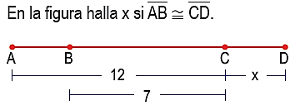

3.



X X

AB + BC = AC

X + 7 = 12

X = 5

Rpta: el valor de x es 5

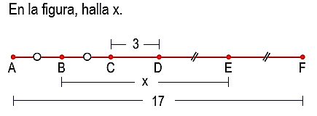

4.

1

2

3

4

5

6

BC + CD + DE = BE

BC + 3 + DE = x

AB + BE + EF = 17

AB + X + EF = 17

AB =BC = a

DE =EF = b

Remplazando 3, 4 en 1 y 2

a + 3 + b = x

a + x + b = 17

(a+b) + 3 = x

(a+b) = x-3

(a+b) + x = 17

x-3 + x = 17

2x = 17 + 3

2x = 20

X = 10



5.

A C D E

b

d

a

a

1

2

3

4

b + d =50

AD = b + a

d = b + 2ª

Remplazando 3 en 1

b + d = 50

b + (b + 2a) = 50

$$\frac{2b+2a}{2}= \frac{50}{2}$$

(b+a) = 25

Remplazando 2

AD = b+a

AD = 25

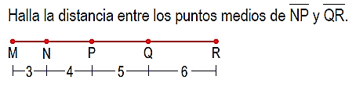

6.

D

F

H

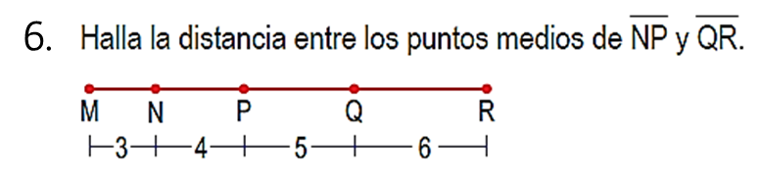

3 3

2 2

D = FP + PQ + QH

D = 2 + 5 + 3

D = 10