Date: Friday 04th November 2022 Final grade 1st “B” secondary

Name Álvaro Yafac Castro

Total Points Written Test (80/100) ____________________ Total Points Speaking Test (20/100) ____________________

A. You will hear three conversations. There is one question for each conversation. Choose the right answer

(A, B, or C). (3 points)

1. What was inside Kelly’s handbag?

A

2. Where is Brad looking for a tablet?

B

1. Which dress is the most expensive?

C

B. Listen to the conversation. Circle the pictures that best express the main topic of the conversation. (3points)

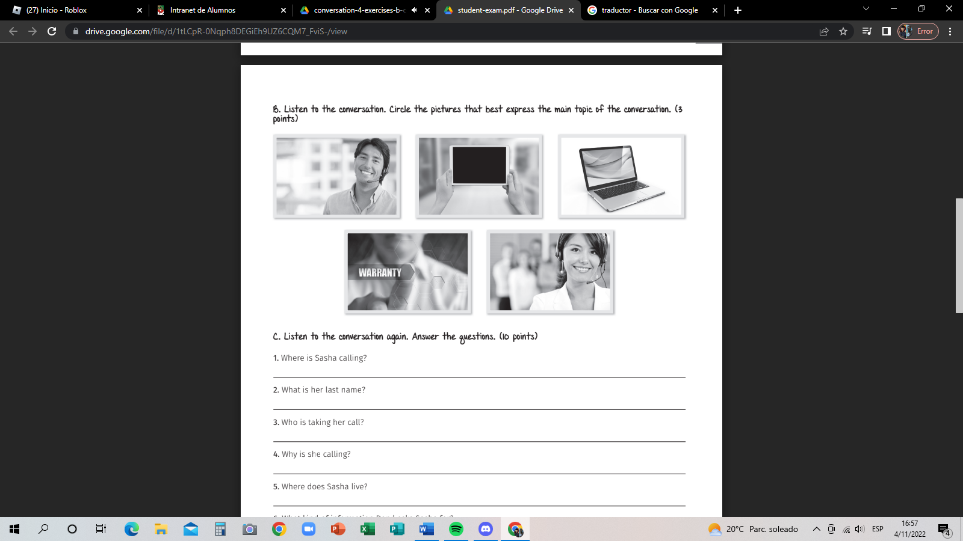

C. Listen to the conversation again. Answer the questions. (10 points)

1. Where is Sasha calling?

She calls to the company federal Traitcomition

2. What is her last name?

Her last name is Thompson

3. Who is taking her call?

Is Darryl Jason

4. Why is she calling?

She is call for a consumer complain

5. Where does Sasha live?

She lives in Oakland California

6. What kind of information Daryl asks Sasha for?

ask for her address, email and phone number

7. What is the company’s name?

Phillips Electronics

8. What is the company’s address?

Is 78 west avenue Buffalo New York 14210

9. Does Sasha know who the company’s representative is?

No, she does not know the representative of the company

10. How long does it take for Sasha to get a response for her complaint?

It will take about 3 or 5 days

4)

Full name: Sasha Thompson

Address: 345 Chart Lane Oakland California 90678

e-mail: [sashathompson@fastmail.com](mailto:sashathompson@fastmail.com)

phone number: 5558742098

5)

1( c )

2(a)

3(b)