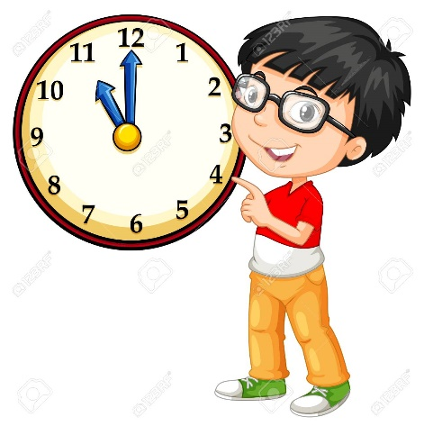

1. **The Present Continuous:** Our neighbors are recycling their things.
2. **Making suggestions:** Why don’t we stay home tonight?
3. **The Time:** It’s a quarter to two.
4. **Vocabulary:** sailing, ancient, arrive, skiing.
5. **Superlative Adjectives:** Going to the museum is the worst thing we could do.
6. **Quantifiers:** There are few crayons in my pencil case. There are a lot of children in my class

“Know our rights and duties”

*THIRD TRIMESTER – VIRTUAL UNIT 8*

*From October 18th – November 12th*

***FIFTH GRADE – ENGLISH***