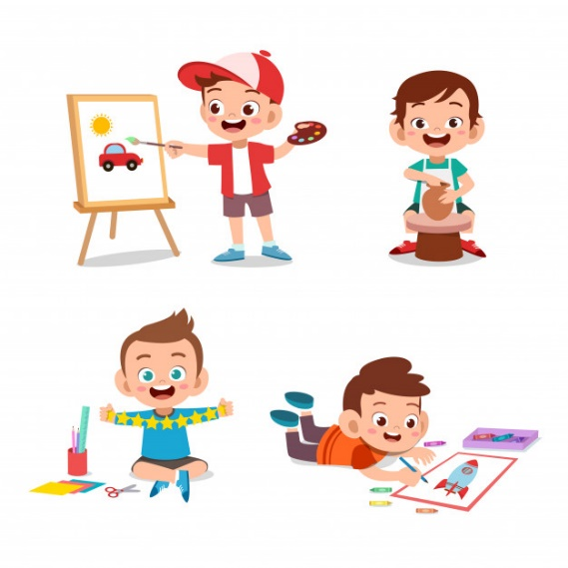 

* **Sports**
* **Do- Does**
* **Hobbies**
* **Sports**
* **Do- Does**
* **Hobbies**

“Let's celebrate our anniversary”

“Let's celebrate our anniversary”



***THIRD GRADE – ENGLISH***

***THIRD GRADE – ENGLISH***

*THIRD TRIMESTER – VIRTUAL UNIT 7*

*From 21 th of September to 16 th of October*

*THIRD TRIMESTER – VIRTUAL UNIT 7*

*From 21 th of September to 16 th of October*