

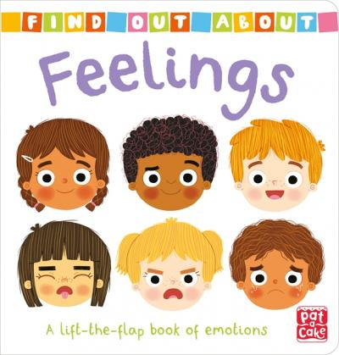

* **Days of the week**
* **Actions**
* **Feelings**
* **Days of the week**
* **Actions**
* **Feelings**

“Let's celebrate our anniversary”

”

“Let's celebrate our anniversary”



***SECOND GRADE – ENGLISH***

***SECOND GRADE – ENGLISH***

*THIRD TRIMESTER – VIRTUAL UNIT 7*

*From 21 th of September to 16 th of October*

*THIRD TRIMESTER – VIRTUAL UNIT 7*

*From 21 th of September to 16 th of October*