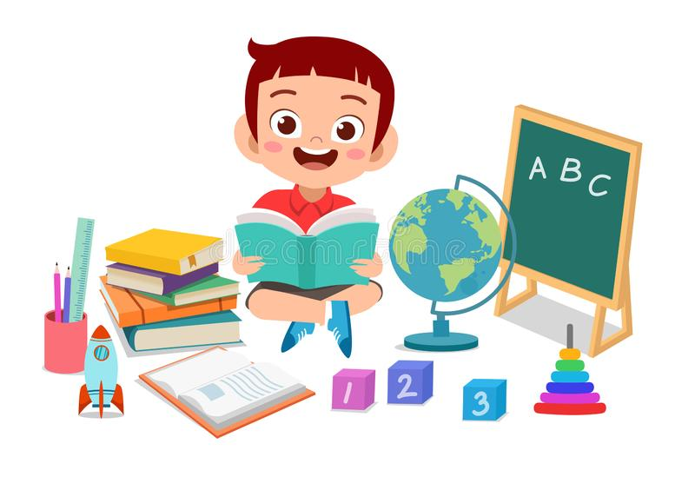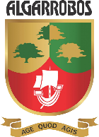

1. **May or Might:** It may rain today.
2. **What things are made of:** A bottle is made of plastic.
3. **Comparative Adjectives:** This place is hotter than the other.
4. **Vocabulary:** plastic, sand, materials, paper, etc
5. **The Present Continuous:** We are learning English now.

“Let´s celebrate our anniversary”

*THIRD TRIMESTER – VIRTUAL UNIT 7*

*From September 20th – October 15th*

***FIFTH GRADE – ENGLISH***